**Nama : Wiwin Nur Kholifah  
NIM : 18090030  
Kelas : 5C**

* Materi

1. Source Code

v_footer.php 🡪 application/views

v_header.php 🡪 application/views

v_index.php 🡪 application/views

v_about.php 🡪 application/viewsstylebook.css 🡪 assets/css

web.php 🡪 application/controllers

1. URL

<http://localhost/web_wiwin/web>

<http://localhost/web_wiwin/web/about>

1. Capture Hasil

* web

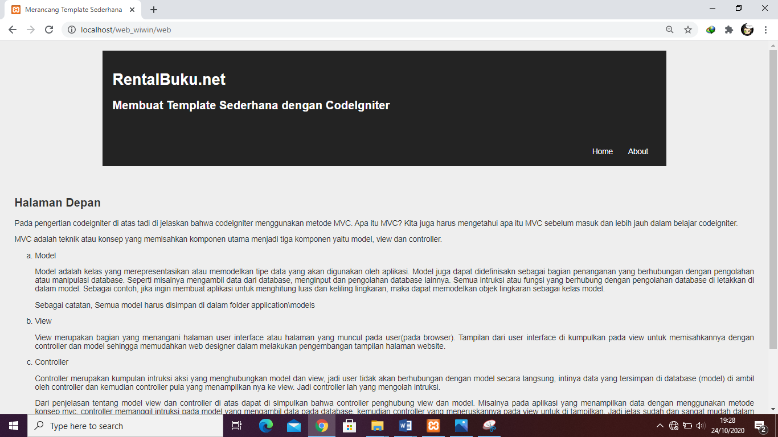

* web/about

